**How to create jobs /Pipeline/CI-CD in Jenkins with both methods step by steps**

**And**

**Jenkins Troubleshooting Steps with Daily Facing issues**

To create jobs (aka *projects*) in Jenkins, you can do it in **two main ways**:

1. **Using the Jenkins Web UI**
2. **Using a Jenkinsfile (Pipeline as Code)**

Here’s a **step-by-step** guide for both methods:

**🔹 1. Using the Jenkins Web UI (Freestyle or Pipeline Job)**

**✅ Step-by-step:**

1. **Access Jenkins**
   * Open your browser and go to: http://localhost:8080
2. **Login**
   * Use your admin credentials.
3. **Click on “New Item”**
   * Top left corner of the Jenkins dashboard.
4. **Enter an Item Name**
   * Give your job a name, e.g., MyFirstJob.
5. **Choose Job Type**
   * Select one:
     + Freestyle project → good for simple tasks like builds or shell commands.
     + Pipeline → if you're writing a Jenkinsfile or want more complex logic.
   * Click **OK**.
6. **Configure the Job**
   * For **Freestyle project**:
     + Add a **build step** like Execute shell, Invoke Ant, Invoke Gradle, etc.
     + You can also configure source code management (e.g., Git), triggers (e.g., build periodically), etc.
   * For **Pipeline**:
     + You can define your pipeline script directly in the textbox or use a Jenkinsfile from your repo.
7. **Save**
   * Click the **Save** button at the bottom.
8. **Run the Job**
   * Click **Build Now** on the left.

**🔹 2. Using a Jenkinsfile (Pipeline as Code)**

A **Jenkinsfile** is a text file that defines your CI/CD pipeline and is usually stored in your project's root directory.

**✅ Step-by-step:**

1. **Create a Jenkinsfile** in your repo:

Groovy

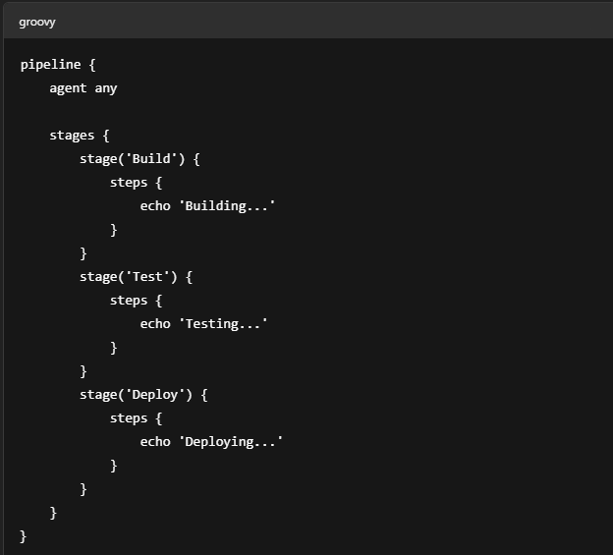

1. **Push it to your Git repository**
2. **Create a New Pipeline Job in Jenkins**
   * Go to Jenkins dashboard → **New Item**
   * Enter a name (e.g., MyPipelineJob)
   * Select **Pipeline**
   * Click **OK**
3. **Configure the Job**
   * Scroll to **Pipeline** section
   * Under *Definition*, choose **Pipeline script from SCM**
   * Select **Git**, then provide your repo URL
   * Enter the script path (default is Jenkinsfile)
4. **Save & Run**
   * Click **Save**
   * Then **Build Now**

### Monitor Pipeline Execution

* **Build History**: View the status of builds in the "Build History" section.​
* **Console Output**: Click on a build number to access detailed logs and output.​
* **Stage View**: Visualize the progress and status of each stage in your pipeline.​

Visual Reference:

## 🛠️ Troubleshooting Jenkins: Common Issues & Solutions

### 1. Jenkins Fails to Start

* **Check Logs**: Review logs located at /var/log/jenkins/jenkins.log for error messages.​
* **Common Causes**:
  + Port conflicts.​
  + Insufficient permissions.​
  + Corrupted configurations.​
* **Solution**: Address the identified issues and restart Jenkins.​

### 2. Out of Memory Errors

* **Symptoms**: Builds fail with java.lang.OutOfMemoryError.​
* **Solution**:
  + Increase Java heap size by modifying Jenkins startup parameters:​

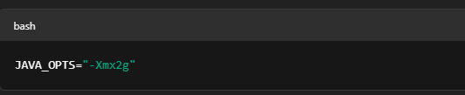

Ensure the system has sufficient RAM.​

**3. Plugin Compatibility Issues**

* **Symptoms**: Plugins not functioning correctly after updates.​
* **Solution**:
  + Verify plugin compatibility with your Jenkins version.​
  + Update or downgrade plugins as necessary.​
  + Restart Jenkins after making changes.​

**4. Disk Space Exhaustion**

* **Symptoms**: Builds fail due to lack of disk space.​
* **Solution**:
  + Check disk usage:​

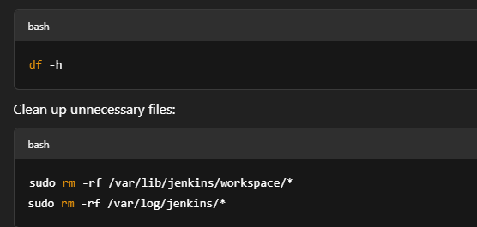

### 5. Pipeline Stages Not Executing

* **Symptoms**: Certain stages in the pipeline are skipped or not executed.​
* **Solution**:
  + Ensure the pipeline syntax is correct.​
  + Check for conditional statements that may prevent stage execution.​
  + Review plugin versions for compatibility issues.​

### ****1. Jenkins Web UI Not Accessible (404 or Connection Refused)****

**Possible Causes:**

* Jenkins service not running
* Port conflict
* Firewall blocking access

**Fix Steps:**

* Check if Jenkins is running:

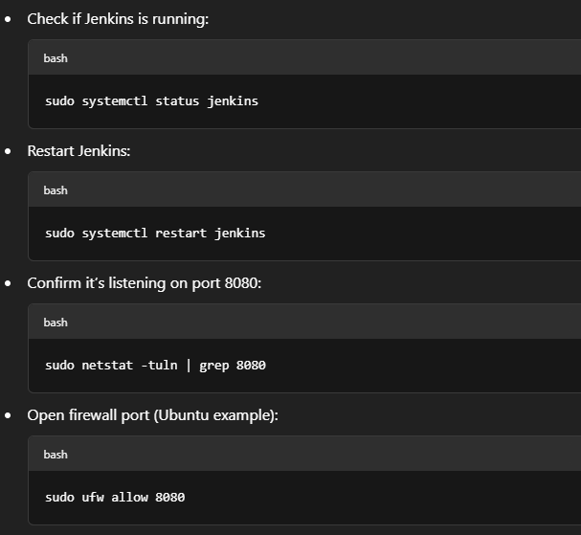

### ⚙️ ****2. Jenkins Pipeline Fails Unexpectedly****

**Possible Causes:**

* Syntax errors in Jenkinsfile
* Missing environment variables or tools
* Plugin issues

**Fix Steps:**

* Validate your Jenkinsfile:
  + Use **Jenkins > Pipeline Syntax Generator**
  + Or use Declarative Linter:  
    http://your-jenkins-url/pipeline-model-converter/validate
* Check console output of the failed build:
  + Look for errors like sh: command not found or Missing stage.

### 🧪 ****3. SCM (Git) Errors in Jenkins****

**Common Errors:**

* Could not read from remote repository
* Permission denied (publickey)
* Repository not found

**Fix Steps:**

* Ensure Jenkins has SSH key access to the Git repo:

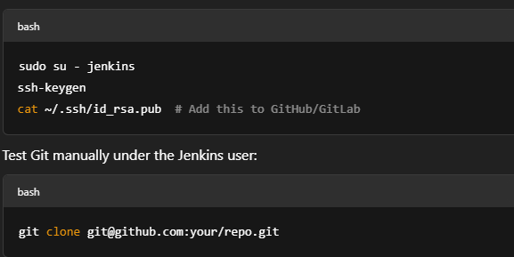

### ****4. Jenkins Workspace Issues****

**Common Symptoms:**

* “Workspace is locked” error
* Old files cause build failures

**Fix Steps:**

* Clean workspace before build:
  + In Pipeline:

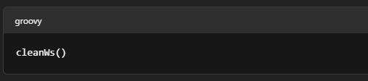

• Or enable **“Delete workspace before build starts”** in job settings

• Manually clean workspace:

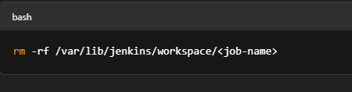

### ****5. Plugin-Related Build Failures****

**Symptoms:**

* Pipeline fails after plugin update
* UI not loading properly

**Fix Steps:**

* Go to: **Manage Jenkins > Plugin Manager > Installed**
* Downgrade plugin if needed (or uninstall and reinstall)
* Clear plugin cache:

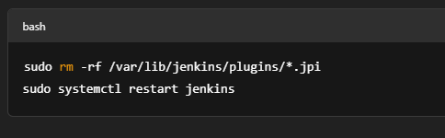

### ****6. Build Queue Stuck or Executors Not Running****

**Symptoms:**

* Jobs stay in “Waiting” state
* No executor picks them up

**Fix Steps:**

* Check Jenkins nodes:  
  **Manage Jenkins > Nodes**  
  Make sure agents are online.
* Restart Jenkins if stuck:

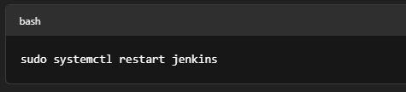

Increase executor count:  
**Manage Jenkins > Nodes > Configure > # of executors**

### ****7. Jenkins Credentials Not Recognized****

**Symptoms:**

* "No credentials available" error
* Pipeline can't access secrets

**Fix Steps:**

* Go to **Manage Jenkins > Credentials**
* Add credentials under correct domain (e.g., global)
* Reference them correctly:



### ****8. Jenkins Slow Performance****

**Causes:**

* Too many builds stored
* Memory leak or low heap size
* Plugin bloat

**Fix Steps:**

* Purge old builds:
  + Enable **"Discard Old Builds"** in job config
* Increase JVM heap:
  + Edit /etc/default/jenkins (or /etc/sysconfig/jenkins)

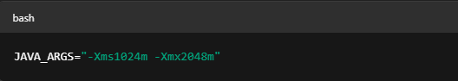

Disable unnecessary plugins

### ****Email Notifications Not Sending****

**Causes:**

* SMTP misconfig
* Missing plugin

**Fix Steps:**

* Install **Email Extension Plugin**
* Configure SMTP in: **Manage Jenkins > Configure System**
* Test with: **"Test configuration by sending an email"**

### ****10. Agents Not Connecting (Slave Offline)****

**Causes:**

* Network issue
* Wrong Java version
* Authentication failure

**Fix Steps:**

* Ensure agent can reach Jenkins master
* Check Java version on agent:

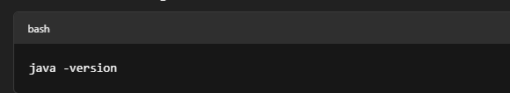

• Reconfigure agent using secret and correct URL

• Restart agent or reconnect via web UI

**Note:**

• 📄 Always check **Jenkins logs** at:  
/var/log/jenkins/jenkins.log

• 🧪 Use the **Blue Ocean plugin** for better visualization of pipeline failures

• 📦 Regularly back up:

* jobs/, plugins/, config.xml, credentials.xml

• 🔄 Automate Jenkins backup using job or external tools like Jenkins Job Builder